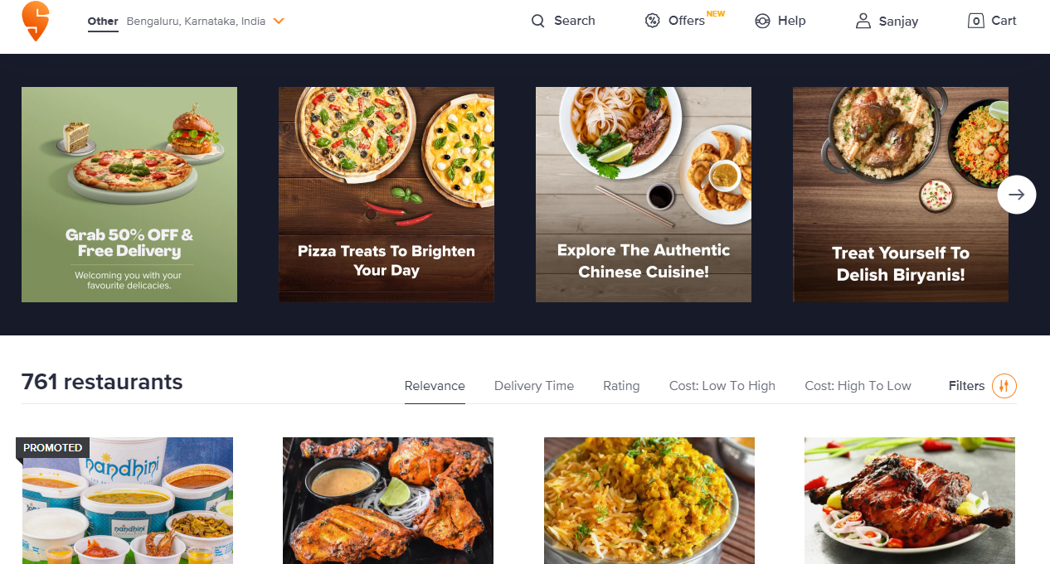

\*OVERVIEW: It’s an food delivery website All kinds of food(veg and non veg) everything is available under the same roof.

* Navigation bar (on top)

⦁ Company name

⦁ Avatar button (login/create account)

⦁ Search bar

⦁ Location selection

⦁ Cart

* Menu bar

⦁ A horizontal division below navigation bar where different categories of items are available to see.

* Filters

⦁ Sort by price

⦁ User rating

⦁ Price ranges

⦁ cuisines

⦁ pure veg

* Item’s list

⦁ Each item in separate division.

⦁ Image of item and name

⦁ Option to buy and add to cart

⦁ User rating

⦁ Restaurant name

⦁ symbol to represent veg and non veg

⦁ Discount offers if available

* Payment gateway

PHONEPE , GOOGLE PAY , BHIM UPI ,CREDIT/DEBIT CARD , NET-BANKING

On reference to site

www.swiggy.com